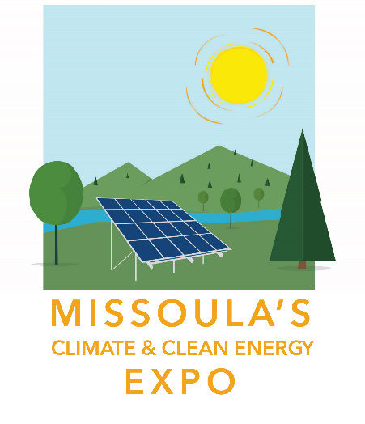
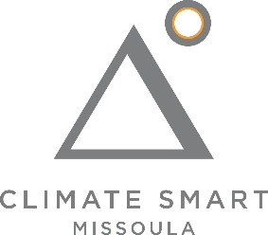
2021 Missoula Climate and
Clean Energy Expo
September 25, Caras Park

Dear Friends,

Please join Climate Smart Missoula for the 3rd Annual Missoula Climate & Clean Energy Expo on Saturday, September 25th, 2021 from 10:00 am – 2:00 pm at Caras Park in Missoula. We hope your organization or business will be able to join us as we build community momentum toward clean energy and a climate resilient future. We are thrilled to be back again!

Mark your calendar now, and join us on September 25th!

Two ways you can participate in this year’s expo:

  - Sponsorship Opportunities: Sponsoring the Climate & Clean Energy Expo gives you the opportunity to demonstrate your commitment to clean energy & climate action and gain exposure for your organization/business. A variety of sponsorship packages are available.

  - Exhibitors: We have spaces available for businesses and organizations in the fields of renewable energy, energy efficiency, sustainability, and other related topics to display information and/or demonstrate their products.

The following pages have additional information on all of these opportunities.

2021 Missoula Climate & Clean Energy Expo
Date: Saturday, September 25th, 2021
Time: 10:00 am – 2:00 pm
Location: Caras Park in Missoula

Contact:
Abby Huseth: abby@climatesmartmissoula.org

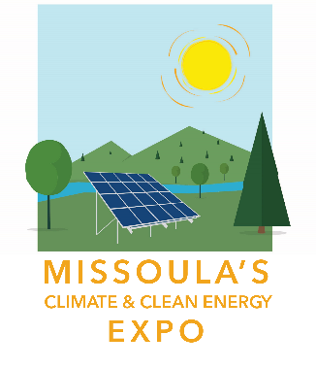
2021 Missoula Climate & Clean Energy Expo
Sponsor/Exhibitor/Vendor Registration Form

Return completed form, with payment, to:

Climate Smart Missoula
RE: Clean Energy Expo
P.O. Box 8945
Missoula, MT 59807

Or register and pay online at:
https://www.missoulaclimate.org/expo-registration.html

Check all that apply:
Sponsor
Exhibitor
For Profit
Non-Profit

Exhibitors / Sponsors (See Page 3 for more information)
One 6’ table and two chairs will be provided for each exhibitor. Limited electrical outlets are available upon request.

Exhibitors: please check the appropriate box describing your exhibit
I will need a table only
My display requires other needs (describe and provide dimensions)
Other Needs/Notes: __________________________________________________

Sponsorship Level:
Gold
Silver
Bronze

Company/Organization:_____________________________________________________________

Contact Name:____________________________________________________________________

Address:_________________________________________________________________________

Phone:___________________________________________________________________________

Email:___________________________________________________________________________

Website:_________________________________________________________________________

Service/Product/Organization description: ________________________________________
_________________________________________________________________________________

Logo: Email a copy of your logo to Abby Huseth, abby@climatesmartmissoula.org

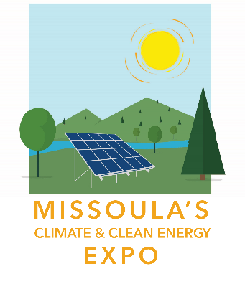

- 2021 Missoula Climate & Clean Energy Expo
Sponsorship Benefits

Demonstrate your commitment to climate action & clean energy by becoming a sponsor of Missoula’s Climate & Clean Energy Expo! Check out the benefits available to sponsors:

Gold Level: $1,000+
- One exhibitor booth
- Your name/logo on online and print promotional materials, including a link on the webpage
- Special verbal recognition at Expo
- Your name/logo on special promotional materials, including an Expo banner
- Mention of your name on radio/TV announcements

Silver Level: $500–$999
- One exhibitor booth
- Your name/logo on online and print promotional materials, including a link on the webpage
- Special verbal recognition at Expo

Bronze Level: $250–$499
- One exhibitor booth
- Your name/logo on online promotional materials, including a link on the webpage

General Exhibitor/Vendor Fees

Before September 3rd, 2021
$50 for non-profits
$150 for for-profits

On or After September 3rd, 2021
$100 for non-profits
$200 for for-profits

2021 Missoula Climate & Clean Energy Expo Exhibitor Requirements

- Vendors and exhibitors must fill out the registration form (Page 2) and be approved by Climate Smart Missoula. You will be notified of your acceptance.

- Climate Smart Missoula reserves the right to refuse exhibits which would detract from the purpose, dignity and intent of Missoula’s Climate & Clean Energy Expo. Climate Smart Missoula reserves the right to stop or remove from the event any exhibitor who performs any practice deemed by Climate Smart Missoula to be illegal, objectionable, or creates a health or safety hazard.

- Exhibitors are responsible for attending their booths at all times. Climate Smart Missoula is not responsible for damages, theft, or loss to exhibitor displays or products displayed at Missoula’s Climate & Clean Energy Expo.

- Vendors and exhibitors agree to hold Climate Smart Missoula harmless from any claim on account of any actions of the vendor/exhibitor, any injury to any person, or damage to any property.

- Vendors and exhibitors shall comply with the laws, rules and regulations of the State of Montana, Missoula County, and City of Missoula.

- Vendors and exhibitors agree to allow Climate Smart Missoula to use images, video and/or audio footage made of the exhibitor or exhibit for promotion of Missoula’s Climate & Clean Energy Expo.

- Vendors and exhibitors can begin setting up at 8:30 am on Saturday, September 25th. Booths must be set up by 9:45 am and must remain open until 2:00 pm.

- Smoking is not allowed in or near Expo activities.

Registering as an exhibitor for the Missoula Climate & Clean Energy Expo indicates that you understand and agree to these requirements. If you have any questions, please contact us.

